FIT3077 Assignment 3

Quarantine Coders Design Rationale

# Extension from Assignment 2

* Observer Pattern – easily adding new Monitor for BP and graphs, each providing their own implementation of the update() method.
* OCP (Patient Data and FHIR Client extension for Blood Pressure)

# Package-level Design Principles

**Package Cohesion**

* **Common Reuse Principle (CRP)**
* **Common Closure Principle (CCP)**

**Package Coupling**

* **Acyclic Dependency Principle (ADP)**

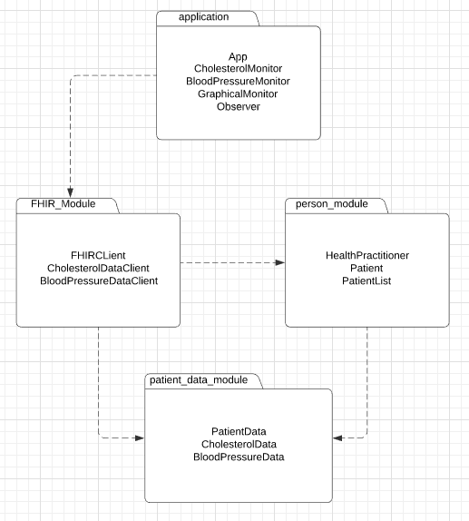

# Refactoring

* Renamed classes and functions to be more coherent with addition of new monitor type.
* Some functions were modified to ensure the app works as intended with new monitor type (highlight_patients, format_data and add/remove patients).

# Class Diagram